
Company
Logotype

Cone Beam Computed Tomography- Report



Porur Dental X-rays & CBCT

Patient Name : Mrs. Vimali | Date of Report : 25.05.2024
Age/ Gender : 41 years/ Female | Region of Interest : CBCT Sectional Mandible
Referring doctor: Dr. S. M. M. Moulvi | Indication : Implant assessment
Clinical Notes: Nil
PATIENT INFORMATION

CBCT- Sectional Mandible provided
CBCT – IMAGE DETAILS

RADIOGRAPHIC INTERPRETATION

- Complete loss of crown and root structure in relation to 31, 41.
- Retained deciduous teeth: 71, 81 with resorptive changes of the root is evident.
- The alveolar bone in relation to the mandibular ridge is present with normal trabecular pattern.

IMPLANT ASSESSMENT

 | 31 region | 41 region
Sub-Crestal (in mm) | 4.35 | 5.42
Mid- Crestal (in mm) | 5.66 | 6.58
Distance between alveolar ridge and the inferior border of mandible (in mm) | 31.42 | 29.96

RADIOGRAPHIC IMPRESSION

- Retained deciduous teeth: 71, 81
- Partial Anodontia: 31, 41.

Kindly correlate with clinical findings


IMAGES FOR REFERENCE

RECONSTRUCTED PANORAMIC VIEW

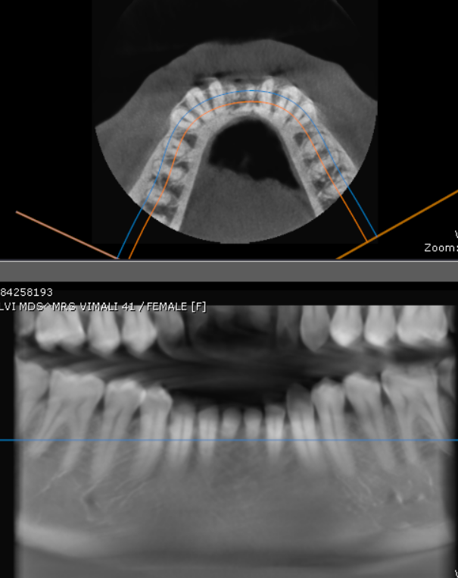

AXIAL VIEW

3-DIMENSIONAL VIEW

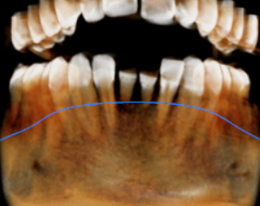

CROSS SECTIONAL VIEW

31 region | 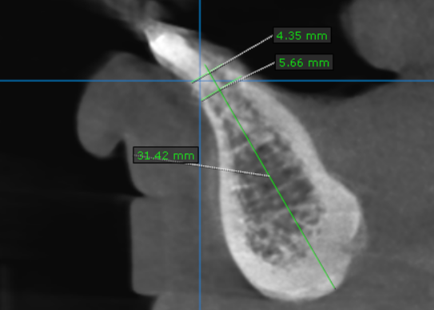
41 region | 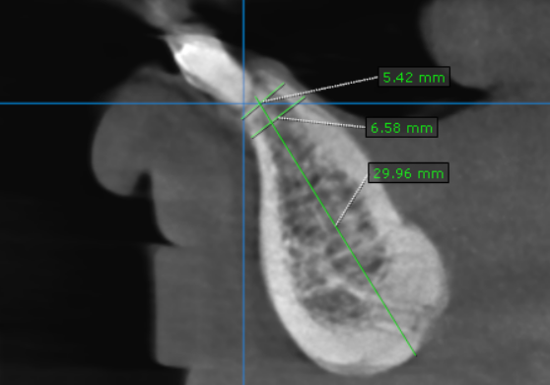

**** End of report ****

